**Livestock Care - Veterinary Assistance and Animal Management**

**Objectives of the Project:**

The primary objective of livestock care is to ensure the health, welfare, and productivity of animals while promoting sustainable farming practices. This encompasses:

1. **Animal Health**: Preventing and treating diseases through veterinary assistance and regular health monitoring.
2. **Welfare and Well-Being**: Providing appropriate living conditions, nutrition, and handling to enhance the overall quality of life for livestock.
3. **Productivity**: Optimizing growth, reproduction, and production (e.g., milk, meat, wool) to meet economic goals while maintaining animal welfare.
4. **Sustainability**: Implementing practices that protect the environment and promote resource conservation for future generations.

By achieving these objectives, livestock care supports both animal welfare and the economic viability of farming operations.

**Brief Introduction of the Project:**

Livestock care is essential for ensuring the health and productivity of farm animals, including cattle, sheep, pigs, and poultry.

It involves a comprehensive approach that integrates veterinary assistance, proper nutrition, and effective management practices.

The primary goals are to promote animal welfare, prevent diseases, optimize production, and implement sustainable farming methods.

By focusing on these elements, livestock care not only supports the animals’ well-being but also enhances the economic viability of agricultural operations, fostering a balance between productivity and ethical responsibility.

**Technology Chosen:**

The technology chosen for development was HTML, CSS and JavaScript because of its scalability and easy deployment.

Agile model was used throughout the development phase to support changes in future.

Database used was mySql which is simple and elegant for current and future use.

The equipment required for deployment of the system was a strong web-server and a windows based hosting.

**Features of the Veternary-care**

1. Login page for doctors and users

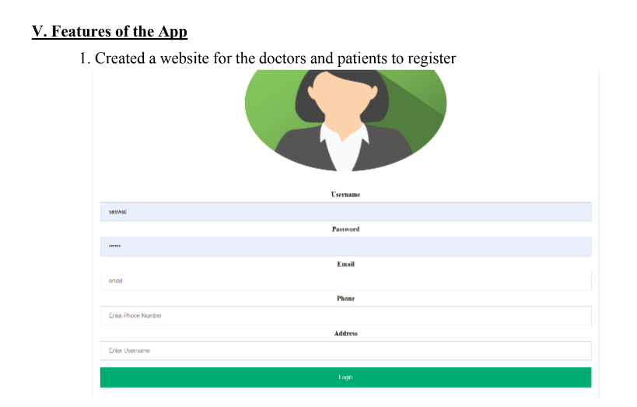

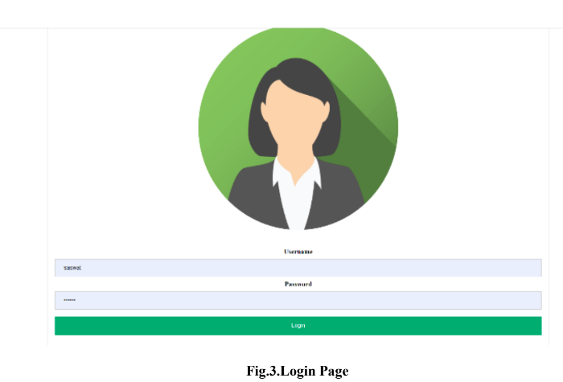

1. Users can choose their prefered languages

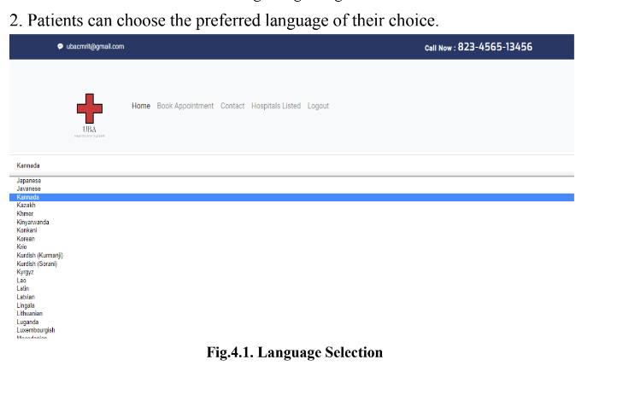



4.Doctors can see booked appointment and confirm if they have a free slot

